SIMATS ENGINEERING (SAVEETHA SCHOOL OF ENGINEERING)
Department of Computer Science and Engineering

CO2 ASSESSMENT TOOL 1 – Scenario-Based Requirement Analysis

Course Code: | CSA10 / CSA1063 | Course Title: | Software Engineering
CO Assessed: | CO2 | Assessment: | Assessment Tool 2 – Scenario-Based Requirement Analysis
Weightage: | 20% | Total Marks: | 25
CO2 Statement: | Perform detailed requirements analysis, design scalable architectures, and prioritize features with a focus on cross-disciplinary skills
Student Name: | M.Kruthika Reddy | Reg. No.: | 192465037
Date: |  | Duration: | 60 minutes
Code of Conduct
I M.Kruthika Reddy/192465037 (Name / Reg No) certify that this submission is my original work and that I have adhered to the guidelines specified for this assessment. I understand that any violation of academic integrity rules will result in disciplinary action.
Signature of the Student:
Annexure A – Scenario-Based Requirement Analysis

Instructions to Students:
Each student will be assigned an individual software project problem statement. Analyze the given scenario and prepare a complete Software Requirement Analysis document by following the steps below.

Question
Based on the assigned problem statement, perform a Scenario-Based Requirement Analysis and prepare a Software Requirement Specification (SRS) document. Your analysis should include the following:

Study and Analyze the Scenario
  - Carefully understand the given problem statement.

The Cloud Security Monitoring and Vulnerability Assessment Dashboard is a software system designed to provide centralized monitoring and security assessment of cloud infrastructure. The system collects security information from cloud resources, monitors activities, identifies vulnerabilities, detects suspicious events, and presents the results through a dashboard. It helps security teams understand the current security condition of cloud resources and take appropriate action against identified risks.
Key Points
Cloud Monitoring: Continuously monitors cloud resources and security activities.
Vulnerability Assessment: Identifies security weaknesses in cloud infrastructure.
Threat Detection: Detects suspicious activities and potential security threats.
Centralized Dashboard: Displays security information in one place.
Security Improvement: Helps organizations identify and reduce cloud security risks.

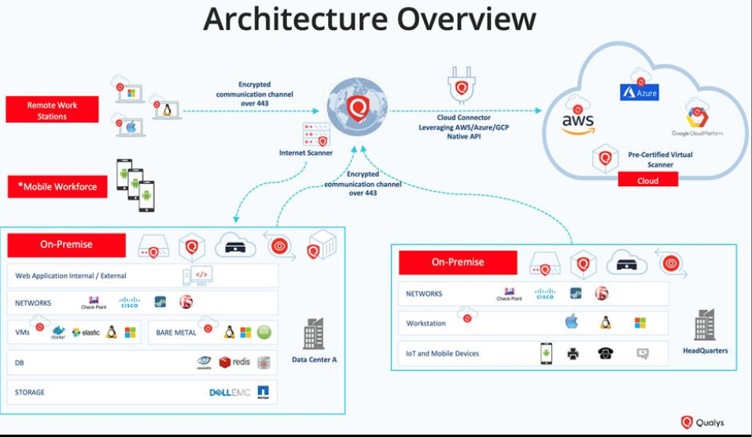

  - Identify the business domain, stakeholders, existing challenges, and system objectives.

The Cloud Security Monitoring and Vulnerability Assessment Dashboard belongs to the Cybersecurity and Cloud Computing domain, focusing on cloud security monitoring, vulnerability assessment, threat detection, and risk management. The key stakeholders include security analysts, cloud administrators, system administrators, developers, management, and end users. Existing challenges include fragmented security monitoring, undetected vulnerabilities, large volumes of security logs, delayed threat detection, and difficulty prioritizing critical risks. The main objective of the system is to provide a centralized dashboard that continuously monitors cloud resources, detects vulnerabilities and suspicious activities, classifies security risks, generates alerts, and provides security reports to help organizations protect their cloud infrastructure.
Key Points
- Business Domain: Cybersecurity and Cloud Computing, specifically cloud security and vulnerability management.
- Stakeholders: Security analysts, cloud administrators, system administrators, developers, management, and end users.
- Existing Challenges: Lack of centralized monitoring, hidden vulnerabilities, large volumes of logs, delayed threat detection, and difficulty prioritizing risks.
- System Objectives: Continuously monitor cloud resources, detect vulnerabilities, identify suspicious activities, and classify security risks.
- Expected Benefit: Provide centralized security visibility, generate alerts and reports, and help organizations respond to cloud security threats effectively.

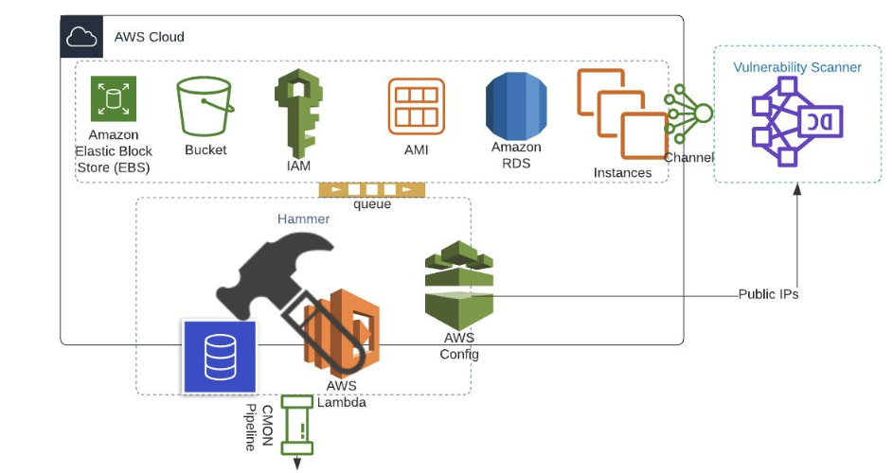

Identify Functional and Non-Functional Requirements
  - List all functional requirements required by the proposed system.

The Cloud Security Monitoring and Vulnerability Assessment Dashboard requires functional features that define what the system must do. The system should provide secure user authentication, monitor cloud resources, collect and analyze security logs, perform vulnerability scans, classify vulnerabilities according to severity, detect suspicious activities, generate security alerts, display security information through a dashboard, and generate reports. These functions allow security analysts and administrators to monitor and manage the security of cloud infrastructure effectively.
Key Points
- User Authentication and Access Control: The system shall allow authorized users to log in and provide role-based access to system features.
- Cloud Resource Monitoring: The system shall monitor registered cloud resources and display their security status.
- Vulnerability Assessment: The system shall scan cloud resources and identify security vulnerabilities.
- Threat Detection and Alerts: The system shall detect suspicious activities and generate alerts with relevant event details.
- Dashboard and Reporting: The system shall display security metrics and generate reports containing vulnerabilities, alerts, and security status.

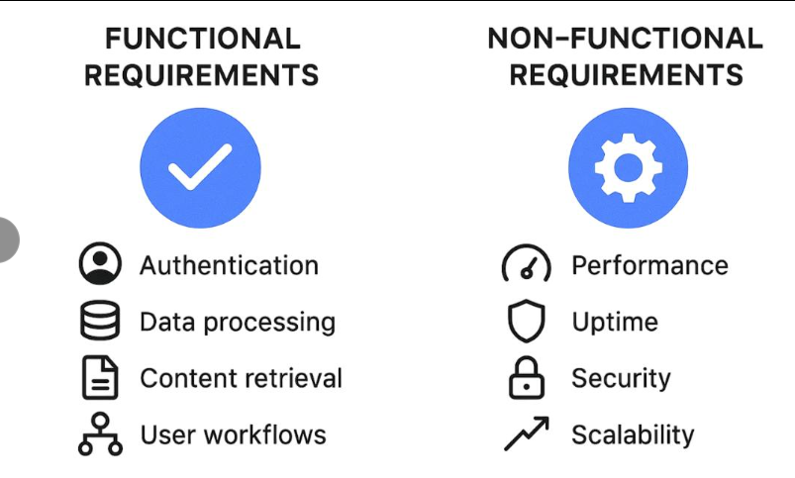
  - Identify suitable non-functional requirements such as performance, security, reliability, usability, scalability, maintainability, and availability.

Non-functional requirements define the quality, performance, and operational characteristics of the proposed system. The dashboard should provide fast responses, strong security, reliable monitoring, ease of use, scalability for increasing cloud resources, maintainable software components, and high availability. These requirements ensure that the system is not only functional but also secure, efficient, dependable, and suitable for continuous cloud security monitoring.
Key Points
- Performance: The dashboard should load security information quickly and process monitoring data with minimal delay.
- Security: The system should use secure authentication, authorization, encryption, and protection against unauthorized access.
- Reliability: The system should provide accurate monitoring results and operate consistently without frequent failures.
- Usability: The dashboard should have a simple, clear, and user-friendly interface that allows analysts to understand security information easily.
- Scalability: The system should support an increasing number of cloud resources, users, logs, and security events without major performance degradation.
- Maintainability: The system should use modular and well-documented components so that updates, bug fixes, and new security features can be added easily.
- Availability: The dashboard should remain accessible for continuous security monitoring and minimize system downtime.

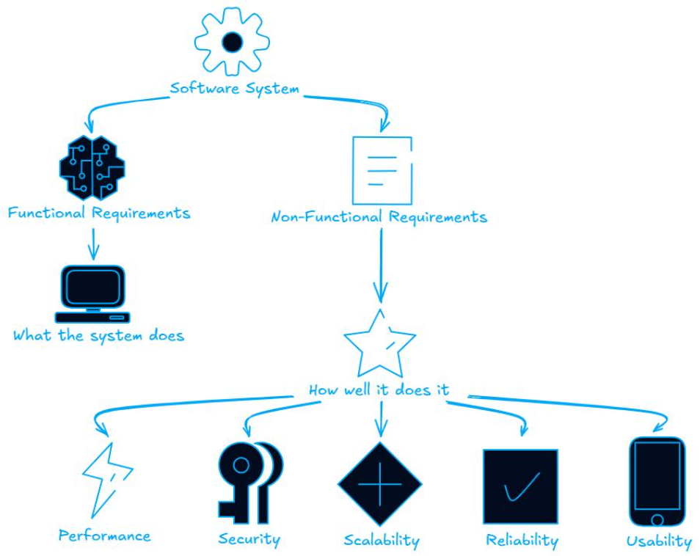

Identify Actors and Use Cases
  - Identify all primary and secondary actors interacting with the system.

The Cloud Security Monitoring and Vulnerability Assessment Dashboard interacts with several actors who use or support the system. The primary actors are the Security Analyst, Cloud Administrator, and System Administrator because they directly use the dashboard for monitoring, vulnerability assessment, and security management. Secondary actors include the Developer, Project Manager/Management, and Cloud Infrastructure/Monitoring Tools, which support the system by fixing vulnerabilities, reviewing reports, or providing security data.
Key Points
- Security Analyst – Primary Actor: Monitors security events, investigates threats, and analyzes vulnerabilities.
- Cloud Administrator – Primary Actor: Manages cloud resources, configurations, and security status.
- System Administrator – Primary Actor: Maintains infrastructure and reviews system security findings.
- Developer – Secondary Actor: Fixes application vulnerabilities identified by the system.
- Management/Project Manager and Cloud Tools – Secondary Actors: Management reviews reports, while cloud monitoring and scanning tools provide security data.

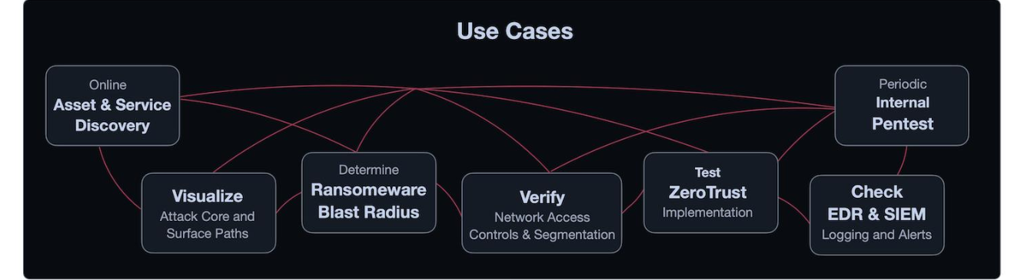
  - List the major use cases associated with each actor.

Each actor performs different activities according to their role in the system. Security analysts mainly monitor events, perform vulnerability assessments, investigate alerts, and generate security reports. Cloud administrators manage cloud resources and review their security status, while system administrators maintain infrastructure and address security issues. Developers use vulnerability results to fix application weaknesses, and management reviews security reports and overall security performance.
Key Points
- Security Analyst: Login, monitor security events, scan vulnerabilities, analyze threats, view alerts, and generate reports.
- Cloud Administrator: Manage cloud resources, monitor resource status, view security events, and review vulnerabilities.
- System Administrator: Monitor infrastructure, view vulnerabilities, prioritize risks, and manage security issues.
- Developer: View application vulnerabilities, analyze findings, and fix identified security weaknesses.
- Management/Project Manager: View security dashboard, review reports, and analyze overall security performance.

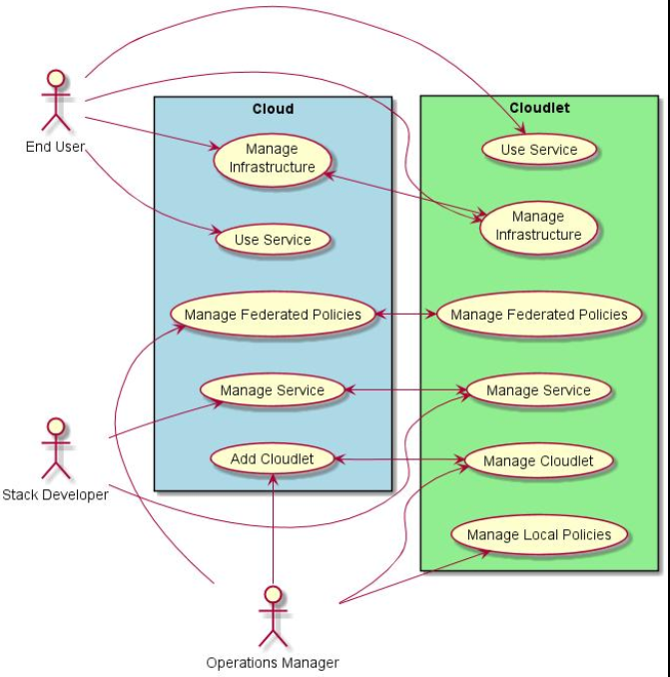

  - Draw a Use Case Diagram representing the interactions between actors and the system.

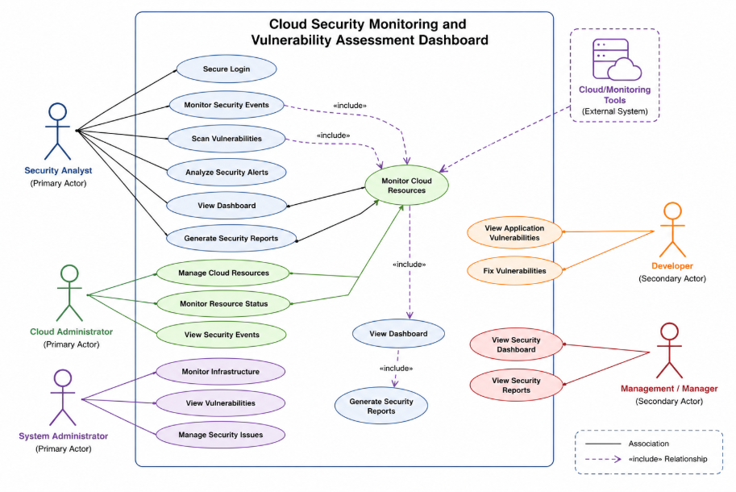

Prepare the Software Requirement Specification (SRS)
Develop an SRS document containing:
  - Introduction

The Cloud Security Monitoring and Vulnerability Assessment Dashboard is a cybersecurity software system designed to provide centralized monitoring and assessment of cloud infrastructure. The system collects security events and vulnerability information from cloud resources and presents them through a user-friendly dashboard. It helps security analysts and administrators identify security weaknesses, monitor threats, prioritize risks, and generate security reports.
Key Points
- Provides centralized cloud security monitoring.
- Identifies vulnerabilities in cloud resources.
- Detects suspicious security activities.
- Provides alerts and security dashboards.
- Supports security analysis and reporting.

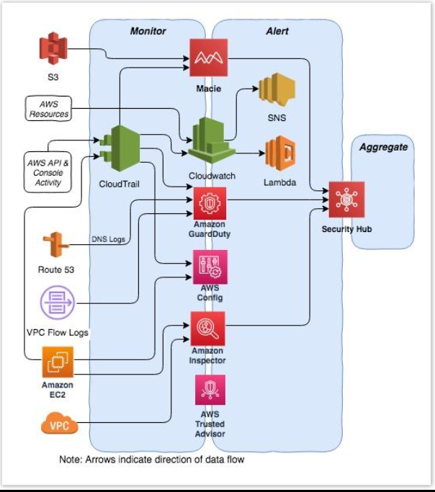
  - Problem Description
Organizations increasingly depend on cloud infrastructure, but monitoring cloud security manually can be difficult due to the large number of resources, users, logs, and security events. Vulnerabilities may remain undetected, and security teams may struggle to prioritize critical risks. Using multiple security tools can also result in fragmented information. The proposed system addresses these problems by providing a centralized dashboard for monitoring, vulnerability assessment, threat detection, and security reporting.
Key Points
- Lack of centralized cloud security monitoring.
- Difficulty identifying vulnerabilities quickly.
- Large volumes of security logs and events.
- Delayed detection of suspicious activities.
- Difficulty prioritizing critical security risks.

  - Scope of the System
The scope of the system includes monitoring cloud resources, collecting security logs, performing vulnerability assessments, detecting suspicious activities, classifying vulnerabilities, generating security alerts, and displaying security information through a centralized dashboard. Authorized users can view security status and generate reports. The system focuses on security monitoring and assessment and does not directly replace cloud infrastructure or perform unauthorized penetration testing.
Key Points
- Cloud resource monitoring.
- Security log and event collection.
- Vulnerability scanning and classification.
- Threat alerts and security notifications.
- Dashboard and security report generation.

  - Functional Requirements

Functional requirements define the operations that the system must perform. The dashboard should support secure authentication, cloud resource monitoring, vulnerability scanning, threat detection, alert generation, security visualization, and reporting. These functions allow authorized users to monitor and manage cloud security from a centralized platform.
Key Points
- User Authentication: Users shall securely log in and access features according to their roles.
- Resource Monitoring: The system shall monitor registered cloud resources and their security status.
- Vulnerability Scanning: The system shall scan resources and identify vulnerabilities.
- Threat Detection: The system shall detect suspicious activities and generate alerts.
- Reporting: The system shall display security metrics and generate security reports.

  - Non-Functional Requirements
Non-functional requirements specify the quality and performance characteristics of the system. The dashboard should be secure, reliable, responsive, scalable, easy to use, maintainable, and highly available. These requirements ensure that the system can support continuous cloud security monitoring while protecting sensitive security information.
Key Points
- Performance: Dashboard operations should respond quickly with minimal delay.
- Security: Authentication, authorization, encryption, and secure data handling must be implemented.
- Reliability: The system should provide consistent and accurate monitoring results.
- Usability: The interface should be simple and easy for security personnel to understand.
- Scalability: The system should support increasing cloud resources, users, logs, and security events.
- Maintainability: The system should use modular and well-documented components.
- Availability: The dashboard should remain available for continuous security monitoring.

  - Use Case Descriptions
The major use cases describe how different actors interact with the system. Security analysts monitor events, scan vulnerabilities, analyze alerts, and generate reports. Cloud administrators manage cloud resources and monitor their status. System administrators review infrastructure vulnerabilities and security issues. Developers view application vulnerabilities and fix identified problems, while management reviews dashboards and security reports.
Key Points
- Login: Authorized users enter credentials to access the dashboard.
- Monitor Cloud Resources: Users view cloud resources, security events, and resource status.
- Scan Vulnerabilities: Security analysts initiate scans and view identified vulnerabilities.
- Analyze Alerts: Analysts investigate suspicious activities and security alerts.
- Generate Reports: Authorized users generate reports containing vulnerabilities, alerts, and security status.

  - Data Requirements
The system requires data related to users, cloud resources, security events, vulnerabilities, alerts, and reports. The collected data should be stored securely and organized so that security analysts can search, analyze, and generate reports efficiently. Sensitive information should be protected using appropriate access controls and encryption.
Key Points
- User Data: User ID, username, role, authentication information, and permissions.
- Cloud Resource Data: Resource ID, resource type, status, configuration, and monitoring information.
- Security Event Data: Event type, timestamp, source, affected resource, and event status.
- Vulnerability Data: Vulnerability ID, description, affected resource, severity, and assessment status.
- Alert and Report Data: Alert details, severity, timestamp, response status, and generated reports.

  - External Interface Requirements
The system requires interfaces through which users and external cloud security services can interact with the dashboard. The user interface should provide login, monitoring, vulnerability, alert, and reporting screens. The system may communicate with cloud platforms, monitoring services, vulnerability scanners, and logging systems through secure APIs or other supported interfaces.
Key Points
- User Interface: Web-based dashboard for authorized users.
- Cloud Interface: Secure connection to cloud resources and services.
- API Interface: APIs for exchanging monitoring and security information.
- Scanning Interface: Integration with vulnerability assessment tools.
- Logging Interface: Collection and processing of security logs and events.

  - System Features
The proposed system provides a set of integrated security features that enable organizations to monitor and assess their cloud environment from a single platform. The major features include secure authentication, cloud resource monitoring, vulnerability assessment, threat detection, risk classification, alerts, dashboards, and security reporting. These features work together to improve security visibility and support faster response to cloud security risks.
Key Points
- Secure Authentication and Role-Based Access Control
- Real-Time Cloud Security Monitoring
- Automated Vulnerability Assessment
- Threat Detection and Security Alerts
- Risk Classification and Prioritization
- Security Dashboard and Visualization
- Security Reports and Analytics

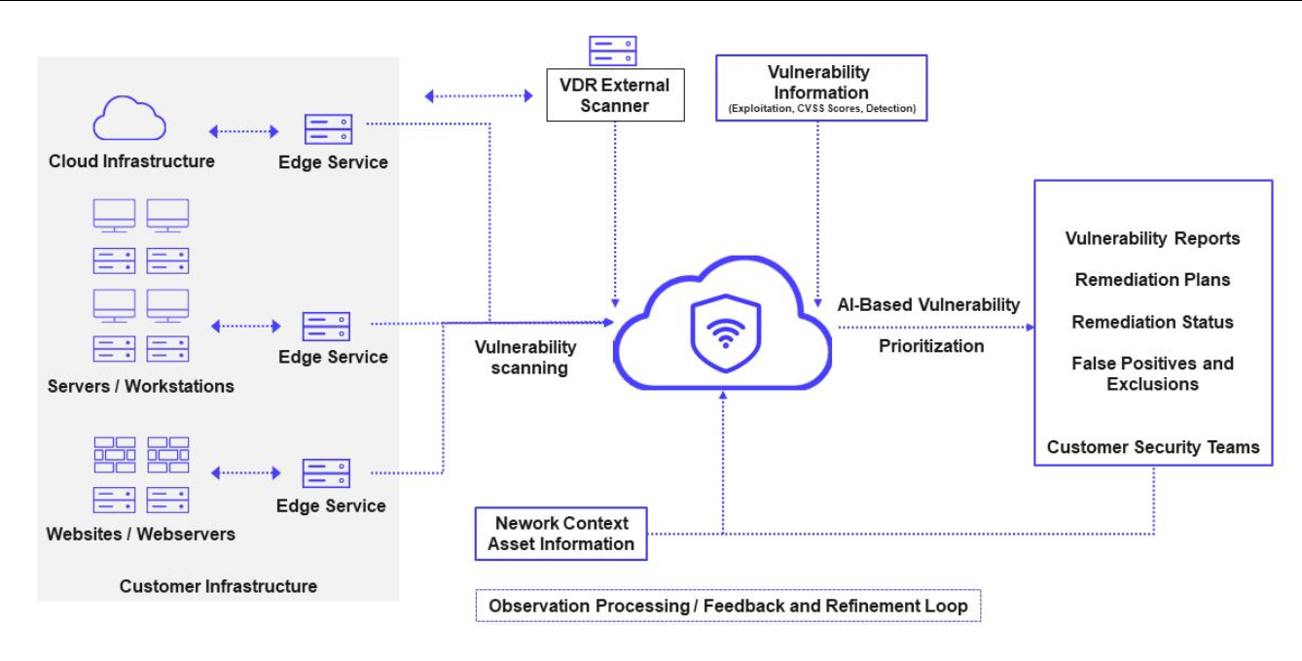

Identify Assumptions and Constraints
  - List the assumptions considered while developing the system.
The development of the Cloud Security Monitoring and Vulnerability Assessment Dashboard is based on several assumptions about the operating environment, users, cloud infrastructure, and available technologies. It is assumed that the organization has authorized access to the cloud resources being monitored and that required security logs and monitoring data are available. It is also assumed that users have basic cybersecurity knowledge and that the necessary cloud services, network connectivity, and security tools are available for system operation.
Key Points
- Authorized Access: The system will have authorized access to the cloud resources and security data being monitored.
- Data Availability: Required cloud logs, events, and resource information will be available for monitoring.
- User Knowledge: Security analysts and administrators are assumed to have basic knowledge of cloud security.
- Network Connectivity: A stable network connection is assumed to be available for communication with cloud services.
- Tool Availability: Required cloud APIs, monitoring tools, and vulnerability assessment tools are assumed to be available and compatible with the system.

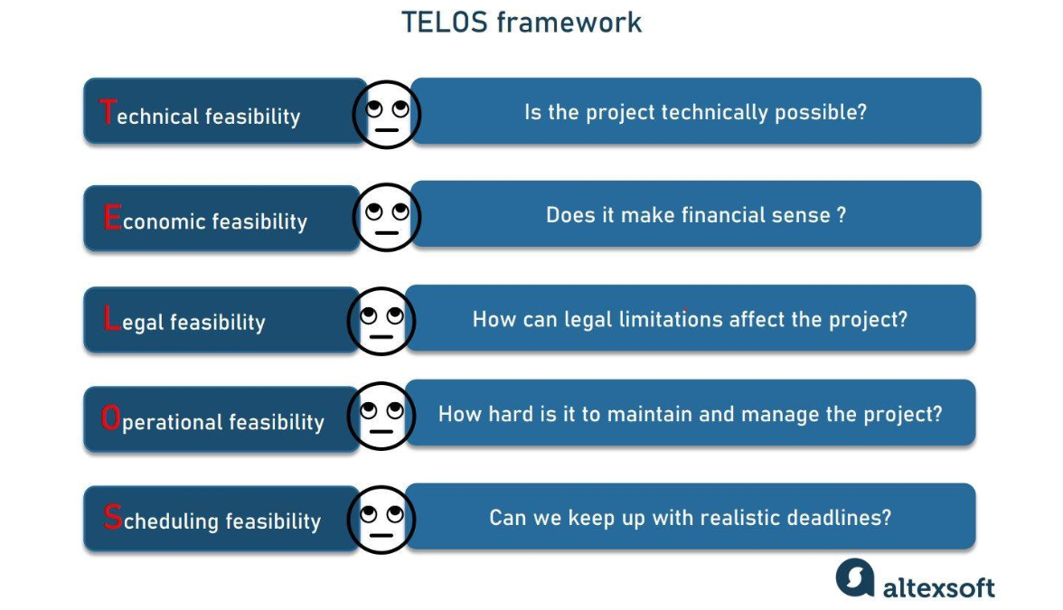
  - Identify technical, operational, economic, legal, and time-related constraints affecting the project.
The project is affected by technical, operational, economic, legal, and time-related constraints. Technical limitations may arise from cloud APIs, system compatibility, storage, and processing capacity. Operational constraints include limited personnel and the need to avoid disrupting production cloud services. Economic constraints may restrict the use of expensive cloud services or security tools. Legal and privacy requirements must be followed when handling security data, while the project must be completed within the assigned academic timeframe.
Key Points
- Technical Constraint: The system depends on compatible cloud APIs, monitoring tools, network connectivity, and available computing resources.
- Operational Constraint: Security scanning and monitoring must not negatively affect or interrupt production cloud services.
- Economic Constraint: The project should use available or low-cost cloud and security tools because the development budget may be limited.
- Legal Constraint: The system must comply with applicable data protection, privacy, access-control, and cybersecurity regulations.
- Time Constraint: The system must be designed, developed, tested, and documented within the assigned project deadline.
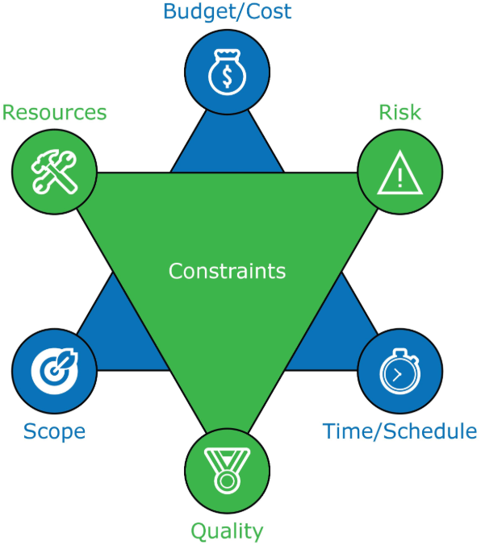

Validate Requirement Completeness and Consistency
  - Verify whether all stakeholder requirements have been addressed.
The requirements of the Cloud Security Monitoring and Vulnerability Assessment Dashboard are reviewed to ensure that the needs of all major stakeholders have been addressed. Security analysts are provided with monitoring, vulnerability assessment, and alert features, while cloud and system administrators receive resource and infrastructure management capabilities. Developers can access vulnerability information, and management can view dashboards and reports. Therefore, the major stakeholder requirements are covered by the proposed system.
Key Points
- Security Analysts: Monitoring, vulnerability scanning, threat detection, alerts, and reports are included.
- Cloud Administrators: Cloud resource monitoring and security status management are included.
- System Administrators: Infrastructure monitoring and vulnerability management are addressed.
- Developers: Application vulnerability information and remediation support are included.
- Management: Security dashboards, reports, and overall security status are provided.

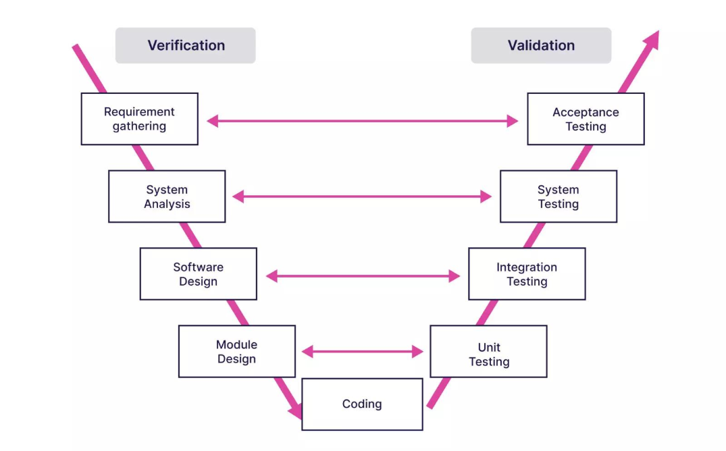
  - Check for ambiguity, redundancy, inconsistency, and missing requirements.
The SRS should be reviewed to ensure that every requirement is clear, unique, consistent, and testable. Similar requirements such as security monitoring and event monitoring should not be unnecessarily repeated. Terms such as “real-time” and “quick response” should be replaced with measurable values where possible. The requirements should also clearly specify supported cloud platforms, severity classification methods, alert conditions, data retention, and system performance expectations.
Key Points
- Ambiguity: Replace unclear terms such as “fast,” “real-time,” and “secure” with measurable requirements.
- Redundancy: Remove repeated requirements for monitoring, alerts, and reporting.
- Inconsistency: Ensure that user roles and permissions are defined consistently throughout the SRS.
- Missing Requirements: Add requirements for data backup, data retention, error handling, audit logs, and recovery.
- Testability: Make every requirement measurable so that it can be verified during testing.

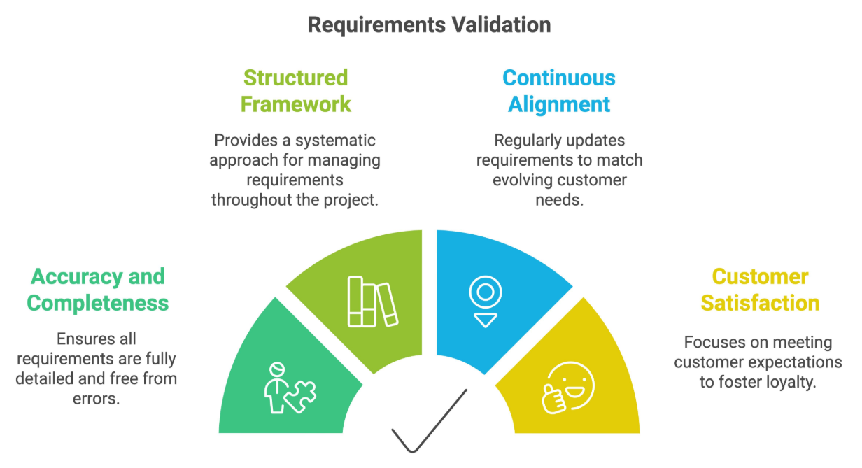
  - Suggest improvements to enhance the quality and completeness of the requirement specification.
The quality and completeness of the SRS can be improved by making requirements specific, measurable, and testable. Each requirement should have a unique identifier and clearly defined priority. The document should also specify supported cloud platforms, security standards, performance targets, data retention periods, backup and recovery procedures, and detailed acceptance criteria. Regular reviews with stakeholders should be conducted to identify new or changing requirements before development is completed.
Key Points
- Use Requirement IDs: Assign unique IDs such as FR-01 and NFR-01 to every requirement.
- Define Measurable Targets: Specify response time, availability, scanning frequency, and alert-generation time.
- Add Security Details: Clearly define encryption, authentication, authorization, and audit requirements.
- Include Error and Recovery Handling: Define how the system handles failures, missing data, and service interruptions.
- Conduct Stakeholder Reviews: Regularly validate requirements with stakeholders to ensure completeness and consistency.

Rubrics for Calculation
Criteria | Excellent (4 Marks) | Good (3 Marks) | Satisfactory (2 Marks) | Needs  Improvement (1 Mark)
Scenario Understanding and Problem  Analysis (30%) | Demonstrates thorough understanding of the scenario, stakeholders, objectives, and  business context with clear analysis. | Demonstrates good understanding with minor omissions. | Basic understanding with limited analysis. | Poor understanding; major aspects missing or incorrect.
Functional and Non-Functiona l Requirement Identification (25%) | Clearly identifies comprehensive, accurate, and well-classified functional and non-functional requirements. | Identifies most  requirements with minor classification errors. | Identifies only basic requirements; several omissions. | Requirements are incomplete, inaccurate, or poorly classified.
Actor Identification and Use Case Modelling (20%) | Correctly identifies all relevant actors and  use cases; use case diagram is complete, accurate, and follows UML standards. | Most actors and use cases  identified; diagram has minor errors. | Limited  actors/use cases identified; diagram partially correct. | Actors/use cases missing or incorrect; diagram absent or inaccurate.
Software  Requirement Specification (SRS) | SRS is  well-structured, complete, professionally | SRS is organized with minor missing sections or formatting issues. | SRS includes only essential sections with limited detail. | SRS is incomplete, poorly organized, or

Documentation (15%) | organized, and  includes all required sections. |  |  | lacks essential components.
Assumptions, Constraints, and  Requirement Validation (10%) | Clearly identifies  realistic assumptions and constraints;  validates requirements for completeness, consistency, and ambiguity with  appropriate justification. | Identifies most assumptions and constraints; validation is adequate. | Limited assumptions/con straints; validation is superficial. | Assumptions, constraints, and validation are missing or incorrect.

Criteria | Mark
Scenario Understanding and Problem Analysis (30%) | /5
Functional and Non-Functional Requirement Identification (25%) | /5
Actor Identification and Use Case Modelling (20%) | /5
Software Requirement Specification (SRS) Documentation (15%) | /5
Assumptions, Constraints, and Requirement Validation (10%) | /5
TOTAL | /25

